Inbox Zero tutorial
Three categories:
Follow up:Things you have to take action on.
Waiting: Some1 else is to take action on, but you’re still responsible for outcome.
For e.g, for a report you want information from some1 that you are writing.
Read Through: ?

Steps:
1)Set Autoadvance I.e after muting,deleting,archiving move to the next newest email.
Also, Enable keyboard shortcuts.
2)Create labels: Follow up, Waiting , Read Through
3) Shortcuts:
L: Label
E:Archive
G+I: Go to inbox + refresh
M: mute, so basically if other ppl reply to this mail, you will not receive notification, unless it is send to u directly.
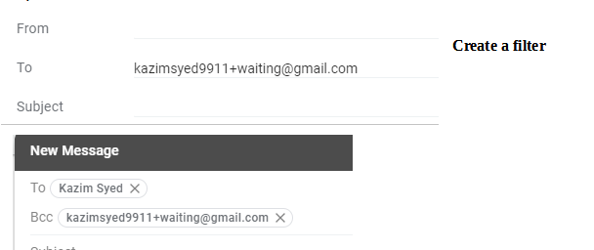
Tip:

Tip: Have multiple inboxes.

